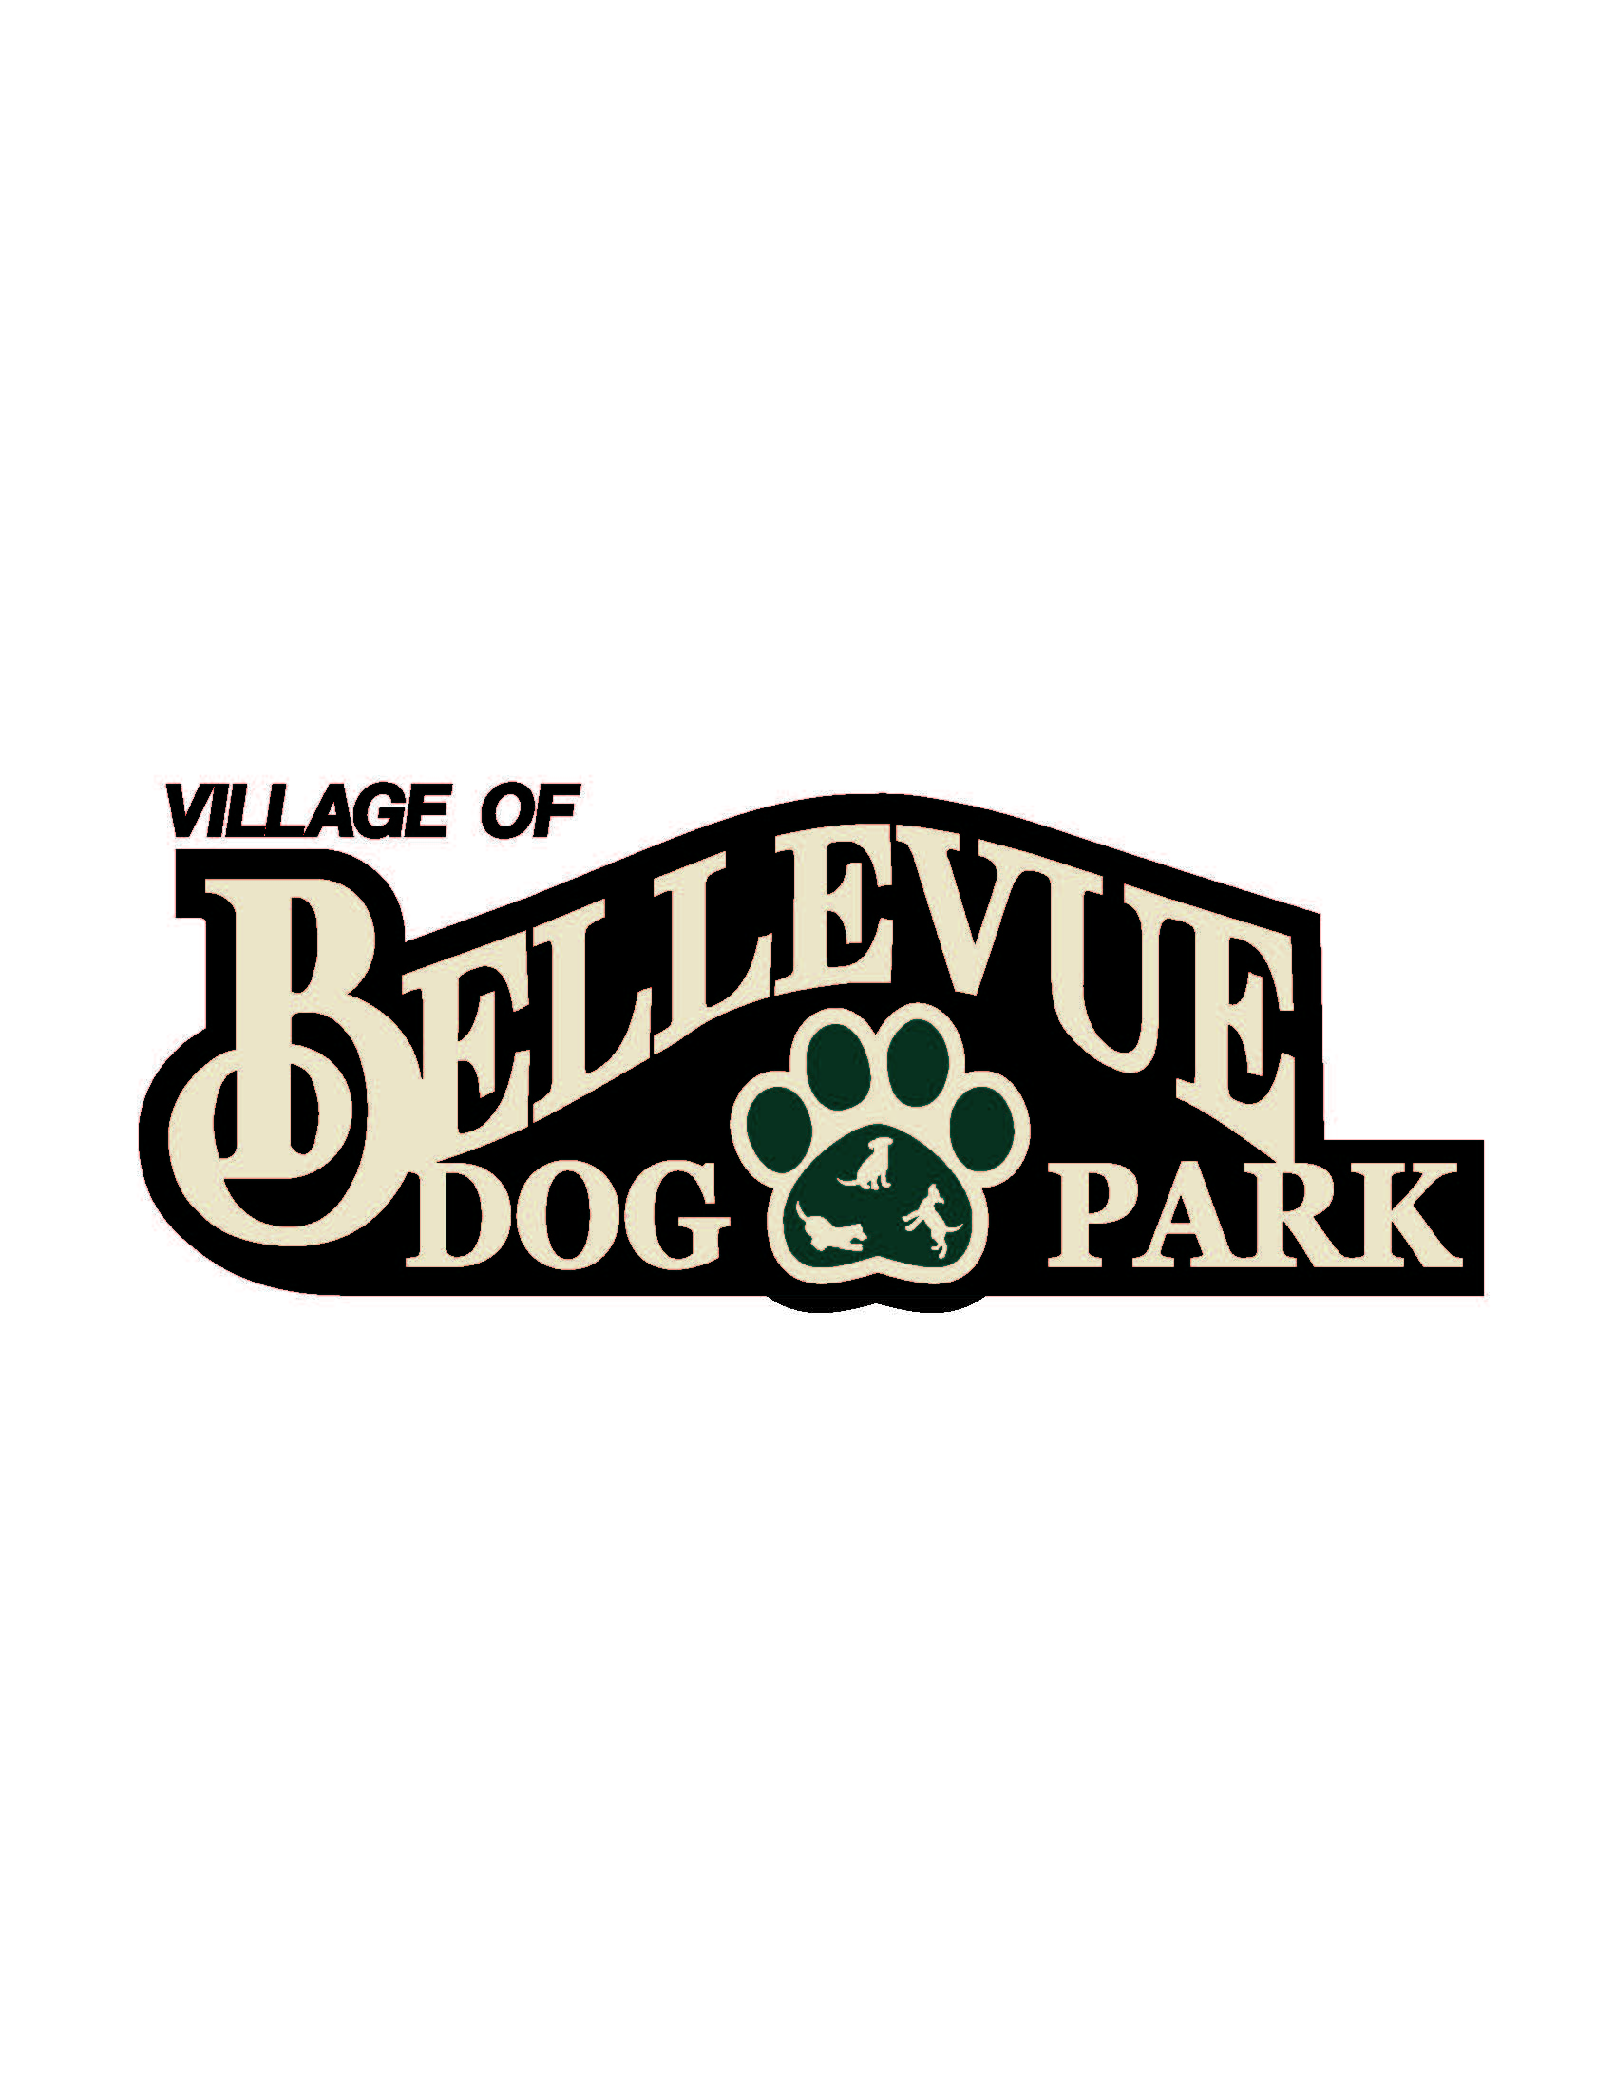
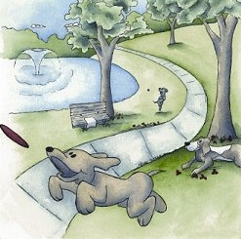

Laura & Peter Mossakowski
Family Dog Park

AGENDA
February 13, 2015
12:30 pm @ Village Hall / Public Safety Building; 3100 Eaton Road
Meeting Topics:

- Welcome & Introductions

- Approval of Minutes

- K9 Karnival Planning

- Committee member to keep track of other members

- Capital Fundraising Campaigns
  - Fund Balance – Recent Donations Update
  - Major Campaign Updates
  - Community Campaign Updates
    - Collection Box Inventory Update
    - Paw Print Sales
    - Basket Raffles/Other
  - Grants/Foundation Updates

- Other Matters

- Next Meeting: TBD

